**Steps for listing the aws users in a file with the help of shell script**

1. **Create an instance and connect with git bash with ssh –key..**
2. **After confirm the ssh connection once connected ..**
3. **Do aws configure by giving details like Access key ID and Security key..**
4. **After configuring AWS CLI..**
5. **Created file as *aws_users.txt***
6. **Created another file to execute the script the file name is  *list_aws_users.sh***
7. **In vi mode script code as writtened in this file *list_aws_users.sh***
8. **After writing the code befor give permissions to that file**
9. ***chmod +x list_aws_users.sh***
10. **Then next execute the file**

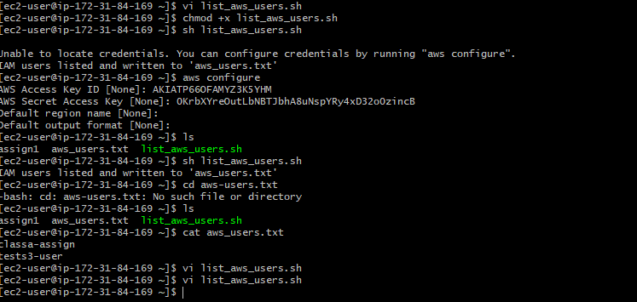

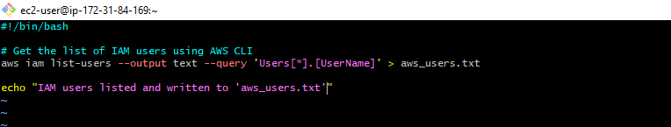

1. **Below image shows that usersdeatils…in AWS Account…**

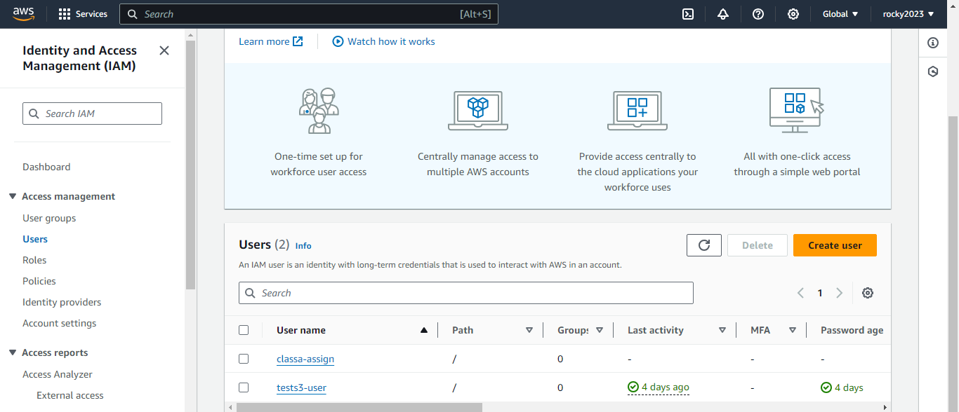

**10)Through shell script listed all users in that particular file in CLI mode below image shown clearly…**

